Manual: Assessing pain and taking a pain history
Written by Yohannes W Woldeamanuel, MD, Ethiopia

This manual is prepared to explain the slides of the presentation ‘Assessing pain and taking a pain history’.
Slide 3
The main topics of the presentation include the following as outlined in the first slide.
- Why is it important to assess pain?
- Why should you use tools to evaluate pain?
- What are the components of the pain assessment process?
- How to optimize pain assessment
- Pain assessment in children & in patients with impaired communication
- Pain evaluation tools which are practical for low-resource settings
- Conclusion: Pearls
Slide 4

Case study

Importance and relevance of making accurate pain assessment
Slides 5
The International Association for the Study of Pain [IASP] defines pain as “an unpleasant sensory and emotional experience, which we primarily associate with tissue damage or describe in terms of such damage, or both.” Current literature advises pain to be considered as the fifth vital sign during a patient examination, next to temperature, pulse rate, blood pressure and respiratory rate.
Pain management depends on how precisely subjective pain complaints have been described. Accuracy of pain assessment not only is important for a proper approach towards pain complaints, but also helps in routing structured, standardized and valid information across different health care providers attending the patient’s pain problems. Pain assessment involves a series of comprehensive description of a patient’s pain, symptoms, functional state and clinical history. Application of specific pain assessment tools significantly aid in arriving at accurate assessment by localizing and quantifying the severity and duration of subjective pain complaints.
Pain assessment process entails of a patient-health care provider dialogue in an attempt to clarify the characters of the pain [location, severity, duration, nature, extent, impact on daily life]. This depends on whether pain levels are permitting or not – some types of pain necessitate immediate intervention. Following appropriate information gathering, available treatment options will be outlined.
Slides 6
Pain assessment is an ongoing process and should occur at:
- each clinical encounter
- regular intervals after initiation of treatment
- each new report of pain
- a suitable interval after pharmacologic or non-pharmacologic intervention [e.g. 15–30 minutes after parenteral drug therapy and 1 hour after oral administration]

Such regular pain evaluation helps in monitoring treatment response and possibility of modifying treatment to ensure delivery of effective pain management.

Components of pain assessment process
Slide 7
A comprehensive pain assessment needs to determine location, description, intensity, duration, alleviating and aggravating factors [alcohol, herbals, and incense], co-morbidities [nausea, vomiting, constipation, confusion, and depression], impact on patient’s life. A mnemonic [PQRST], reminding these components, is presented in the following table and slide 8.
‘PQRST’ approach
P: Provokes and Palliates | - What causes the pain?  - What makes the pain better?  - What makes the pain worse?
Q: Quality | - What does the pain feel like?  - Sharp? Dull? Stabbing? Burning? Crushing?
R: Region and Radiation | - Where is the pain located?  - Is it confined to one place?  - Does the pain radiate? If yes, where to?  - Did it start elsewhere and now localized to one spot?
S: Severity | - How severe is the pain?
T: Time | - When did the pain start  - Is it present all the time?  - Are you pain-free at night/day?  - Are you pain-free on movement?  - How long does the pain last?

At the first encounter, a broader assessment needs to be made with supplemental questions including:
- Past history of pain
- Patient’s current diagnoses and past medical history [e.g. diabetes, arthritis]
- History of surgical operations/other medical disorders
- Recent history of trauma
- History of cardiac illness, lung problems, stroke, hypertension
- History of medication/drugs
- History of allergies
- Worsening of pain on deep inspiration
- Patient’s history of psychosocial status
- Patient’s functional status [activities of daily living]

Elements of ensuring an effective pain assessment process
Slides 9-12
- Patient’s self-reported pain should be accepted as accurate: A patient’s self-reported pain is the primary and accurate source of information. Behavioral or verbal pain expression, being subjective in nature, is influenced by a multitude of factors – of which gender differences, socially acceptable pain thresholds, culturally acceptable levels of complaining, sense of hopelessness, diminished morale, coping and adaptation abilities, and the connotation attached to the pain experience are some examples. Here, it should be remembered that some patients may exceptionally exaggerate their pain experience and misguide the pain assessment process. Observational report from health care providers cannot replace a patient’s self-reported pain as a source of information. [slide 10]
- Allow patients express their pain in their own words: Patients may report their pain experience in socially acceptable words. Health care providers should make a sensitive exploration of what is expressed. In situations when patients feel uncomfortable to express their pain, health care providers may need to provide a sample of relevant descriptors written on cards. [slide 11]
- Listen actively to what the patient says. To ensure what the patient expresses gets clearly conveyed, the pain evaluator should focus on the patient, observe his/her body language and paraphrase his/her words. Non-verbal descriptors need to be noted during emotionally charged encounters. It is also important to avoid distracting the patient. [slide 12]
- Help illustrate location and radiations of pain. Patients are requested to indicate primary site/s of pain by shading relevant areas of the figure of a human body. Demonstrating direction of any radiating pain is helpful. Elland Color scale can be used for illustration of pain location in children [as explained below]. [slide 13]
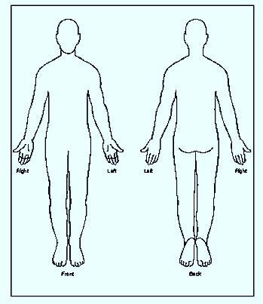
Human body drawing [front and back] that can be applied to shade areas of primary pain site/s.

- Using pain scales: Severity of pain needs to be determined using pain scales. A number of pain scales exist with varying complexity and methodological precision [to be discussed in the later parts].

Eland Color Scale for Children: Directions for Use [slide 12]
[J.M. Eland from McCaffery and Beebe, 1989]

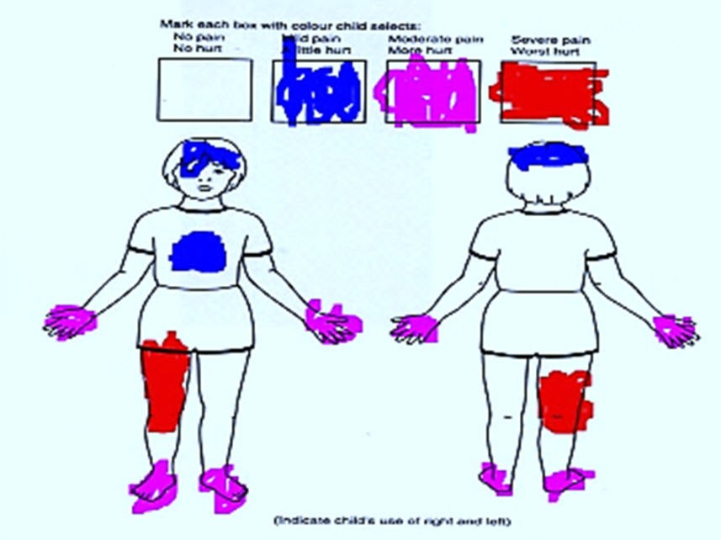
Eland Color Scale
After discussing with the child several things that have hurt the child in the past:
- Present eight crayons or markers to the child. Suggested colors are yellow, orange, red, green, blue, purple, brown, and black.
- Ask the following questions, and after the child has answered, mark the appropriate square on the tool (e.g., severe pain, worst hurt), and put that color away from the others. For convenience, the word hurt is used here, but whatever term the child uses should be substituted. Ask the child these questions:
- "Of these colors, which color is most like the worst hurt you have ever had, (using whatever example the child has given) or the worst hurt anybody could ever have?" Which phrase is chosen will depend on the child's experience and what the child is able to understand. Some children may be able to imagine much worse pain than they have ever had, while other children can only understand what they have experienced. Of course, some children may have experienced the worst pain they can imagine.
- "Which color is almost as much hurt as the worst hurt (or, use example given above, if any), but not quite as bad?"
- "Which color is like something that hurts just a little?"
- "Which color is like no hurt at all?"
- Show the four colors (marked boxes, crayons, or markers) to the child in the order he has chosen them, from the color chosen for the worst hurt to the color chosen for no hurt.
- Ask the child to color the body outlines where he hurts, using the colors he has chosen to show how much it hurts.
- When the child finishes, ask the child if this is a picture of how he hurts now or how he hurt earlier. Be specific about what earlier means by relating the time to an event, e.g., at lunch or in the playroom.

Duration of the pain assessment
Slide 13
Length of pain assessment depends on the presenting problem/s and the specific demands on clinic time. The quality of pain assessment is more important than the quantity of time spent on assessing the pain.

Patients with barriers to communication
Slide 14
Patients with barriers to communication can affect pain assessment. These include:
• children
• individuals of advanced age (e.g., greater than 85 years)
• patients with emotional or cognitive dysfunction
• patients who are seriously ill
• patients in whom English is a second language or who are non-English speaking

General approach of pain assessment
Slide 15-16
  - Allow sufficient time for the assessment.
  - Use a language interpreter if language of communication is second language.
  - Give the patient the opportunity to use a rating scale or other tool appropriate for that population.
  - Use indicators of pain according to the following hierarchy of importance:
- Patient self-report
- Pathological conditions or procedures known to be painful
- Pain-related behaviors (e.g., grimacing, restlessness, vocalization)
- Reports of pain by family members or caretakers
- Physiological measures (vital signs)
- Reliance on behavioral or objective indicators of pain (e.g., vital signs) only when no suitable alternative exists

Assessment in acute pain situations
Slide 17
Treat while making assessment: To manage a patient’s pain, one is not obligated to wait for the diagnosis. Diagnosing the cause of the pain and treating it accordingly ensures a long-term resolution to the presenting pain problem. s

Pain assessment in children
Slide 18
The tenet that children do not feel pain due to underdeveloped neurological systems has been a misconception. Children do experience pain; however their pain expression makes pain evaluation more challenging. Baker and Wong [Baker and Wong, 1987] devised the following approach mnemonic as QUESTT as a guide for pain evaluation in children.
‘QUESTT’ approach
- Question the child if he/she is able to verbalize his/her pain experience, and the parent/guardian in both the verbal and non-verbal child
- Use pain rating scales if appropriate
- Evaluate behavior and physiological changes
- Secure the parent’s involvement
- Take the cause of pain into account
- Take action and evaluate the results

For all children, irrespective of their age group, pain assessment is better done with the presence of family/guardian. At the different age groups, children present distinct challenges for pain assessment. These challenges are discussed below along with recommendations.
Neonates: 0-1 month Slide 19
Behavioral observation, accompanied by child’s family/guardian to discern between ‘normal’ and ‘abnormal’ behavior, is the only way of pain assessment at this age. Lack of behavioral responses [facial expressions e.g. crying, and discomforted movement] does not always mean absence of pain. Thus, behavioral responses are not necessarily accurate indicators of the neonate’s level of pain experience.
Infants: 1 month to 1 year Slide 20
Infants may exhibit the following during pain: body rigidity/thrashing, facial expression of pain [brows lowered and drawn together, eyes tightly closed, mouth open and squared], loud and intense cries, inconsolability, hypersensitivity/irritability, drawing knees to chest, poor food intake, poor sleep.
Toddlers: 1-2 years Slides 21-24
Toddlers may exhibit the following during pain: verbal aggression, intense cries, regressive behavior/withdrawal, physical resistance, guard painful part of the body, and poor sleep. Toddlers may require engaging them into play and drawings to get an accurate assessment of their pain. Some may express their pain using simple language.

FLACC behavioral pain scale Slides 22-24
The FLACC applies to children [2 months to 7 years old] who are unable to verbalize their pain experience. Prior to going to the evaluation steps, for a child who is awake, the health care provider must observe the child [undressed] for a period of 2-5 minutes. This is followed by the health care provider repositioning the child and observing the child’s activity, at the same time assessing the child’s body for tenseness and tone. Consolations may be important in between. If the child is sleeping, the health care provider should observe the child undressed for more than 5 minutes.
The FLACC tool is categorized into five parts assessing the face, legs, activity, cry and consolability, with each part given a score ranging from 0-2 [Merkel et al, 1997]. The final score can be grouped as Score 0 for relaxed and comfortable; Score 1-3 for mild discomfort; Score 4-6 for moderate pain; Score 7-10 for severe discomfort/pain.
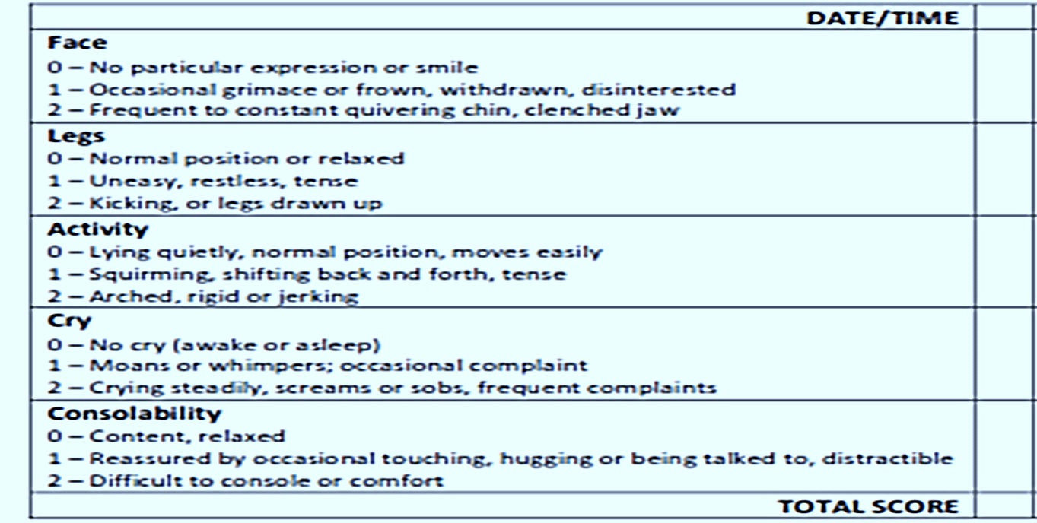
The FLACC scale

Instructions:
1. Each of the five (5) categories is scored from 0-2, which results in a total score between 0 and 10.
(F) Faces (L) Legs (A) Activity (C) Cry (C) Consolability
2. The interdisciplinary team in collaboration with the patient/family (if appropriate), can determine appropriate interventions in response to FLACC Scale scores.
Advantages: useful among children unable or unwilling to report pain; it is quick to do, and is easily reproducible.
Disadvantages: not validated for neonates, children with special needs, or ventilated children

Pre-school: 3-5 years Slides 25-26
The pre-schooler may exhibit the following during pain: may verbalize his/her pain, thrash arms and legs, pushes stimuli away before they are applied, be uncooperative, need physical restraint, cling to their parent/guardian, need emotional support [e.g. hugs], and have poor sleep. Assessment should be at a tempo, using simpler language and sympathetic demeanor.
School-age: 6-12 years Slides 27-28
The school-aged may exhibit the following during pain: verbalize their pain, may even ask what causes their pain, may need age-appropriate responses [You have pain in your stomach because you have a lump there which is making it hurt’ ], may be influenced by cultural beliefs, may experience pain-related nightmares, may show stalling behaviors [e.g. ‘wait a minute’, ‘I’m not ready’], may show muscular rigidity [e.g. clenched fists, white knuckles, gritted teeth, contracted limbs, stiff body, closed eyes, wrinkled forehead], may have reservation in fear of consequences [e.g. injection]. School-aged may also show all behaviors of the pre-school children.
Pain thermometer
The pain thermometer applies a scale mimicking a thermometer that shows an increasing intensity of pain adapted from the verbal descriptor scale [described earlier]. The child will be asked to imagine a thermometer with its heat inside rising with rising temperature and use it as an analogy for the intensity of pain.
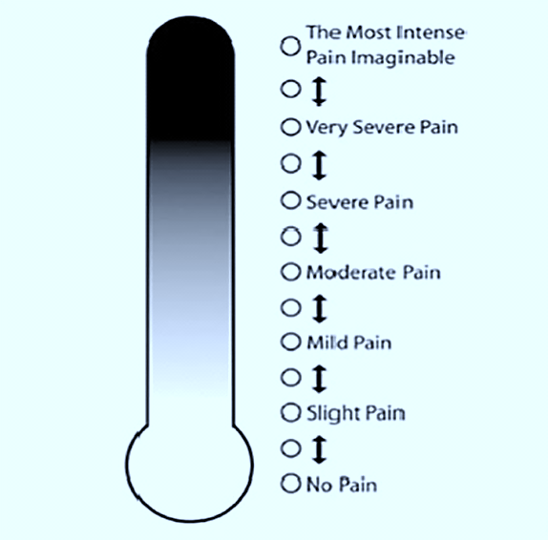
The Pain thermometer
Advantages: simple and quick to use, intuitively preferred by some patients instead of expressing their pain intensity numerically
Disadvantages: while overcoming some of the limitations of the verbal descriptor scale by providing an accompanying illustration of pain intensity, the tool may be problematic among the cognitively or visually impaired.

Adolescents: 13-18 years Slide 29
Adolescents can verbalize their pain experience. They may deny pain in the presence of peers, influenced by peer pressure. They may also have changes in sleep pattern or appetite. Health care providers should avoid confrontation and engage conversation focused on the adolescent rather than the problem [informal questions about friends, school, hobbies, family]. Health care providers need to avoid deliberate moments of silence.
REMINDER
An age- appropriate pain evaluation tool needs to be selected. Behavior alone is not a reliable indicator of experienced pain. Self-reporting has potential limitations. Use physiological pain indicators [e.g. changes in blood pressure, heart rate, respiratory rate] with care – they are not necessarily reliable over time.

Numerical and Verbal Rating Scales: Slide 30
Numerical Pain Scale: This is a unidimensional pain scale measuring pain intensity with the patient asked to describe his/her level of pain experience between ‘0’ rated as ‘No pain’ to ‘10’ rated as ‘Worst pain imaginable’.
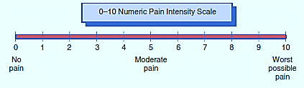
The Numerical Rating Scale
Instructions:
1. The patient is asked any one of the following questions:
- If ‘0’ represents having NO PAIN and ‘10’ represents the WORST POSSIBLE PAIN, what number would you give to assess the intensity of your pain right now?
- What number would you give, when your pain is the worst that it gets and when it is the best that it gets?
- At what number is the pain at an acceptable level for you?

2. When the explanation suggested in #1 above is not sufficient for the patient, it is sometimes helpful to further explain or conceptualize the Numeric Rating Scale in the following manner:
- 0 = No Pain
- 1-3 = Mild Pain (nagging, annoying, interfering little with activities of daily living – ADLs – consisting of self-care tasks such as personal hygiene and grooming, dressing, self-feeding, transferring in and out of bed or wheelchair, managing medications, using the phone, toileting)
- 4–6 = Moderate Pain (interferes significantly with ADLs)
- 7-10 = Severe Pain (disabling; unable to perform ADLs)

3. The interdisciplinary team in collaboration with the patient/family (if appropriate); can determine appropriate interventions in response to Numeric Pain Ratings.
Advantages: quick and simple to use, easy to score and document the results, and compare with previous ratings. This tool is well-validated [in acute and chronic pain, rheumatic disease, trauma, cancer, illiterate] and can be translated to other languages, it can be used to assess intensity of treatment-related side effects. It is easy to teach patients its correct use. It can be used in patients with reduced vision and physical impairment, and also makes possible to report pain intensity over the telephone.
Disadvantages: some patients are unable to complete the tool with only verbal instructions. Consequently, there is decreased reliability at the age extremes, and with non-verbal and cognitively [visual/auditory dysfunction] impaired patients.
Verbal descriptor scale: slide 30 (cont)
Patients are asked to select one of the six adjectives below which best fits the level of pain intensity they are experiencing.
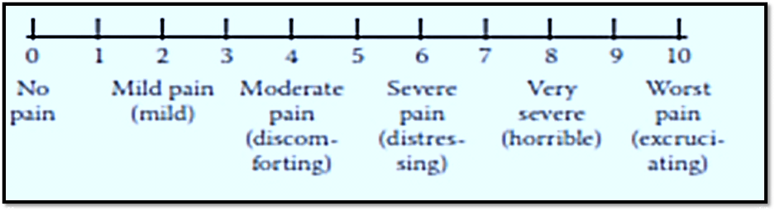
The Verbal descriptor scale
Advantages: quick and easy to use, easily understood, well-validated [on adults] and sensitive to treatment effects; intuitively preferred by some patients instead of expressing their pain intensity numerically. It can be preferred by older adults compared to the NRS.
Disadvantages: based on the use of language to describe pain, the tool depends upon a person’s interpretation and understanding of the descriptors; which can prove to be a challenge in different cultures. The tool is problematic for use among the very young or old, the cognitively impaired and the illiterate.

Pain assessment among the aged
Slide 31
The United Nations definition of ‘older people’ which is linked to legal entitlement of age-specific benefits from formal employment sectors may not apply for sub-Saharan Africa where complex and multi-dimensional socio-cultural definitions exist [e.g. seniority status, number of grandchildren]. It is challenging to assess pain among geriatric patients with multi-morbidity, multi-medication and dementia. Visual and hearing impairment may be obstacles. Use of behavior-based proxies may be important in non-communicative cases. In principle, for the geriatric patient: Ask for Pain.

Pain evaluation tools practical for low-resource setting
Slide 32
There are unidimensional and multidimensional pain evaluation tools in practice today. Unidimensional tools that focus on a single dimension of the pain evaluation [e.g. severity] are more practical in low-resource, non-research clinical setting because they take shorter time to administer, require less level of patient’s education, validated in linguistically and culturally diverse settings.

Examples of pain evaluation tools applicable for low-resource settings include: the African Palliative Outcome Scales [APOS], the Visual Analogue Scale [VAS], the Numerical Rating Scale [NRS], the Verbal Descriptor Scale [VDS], the FLACC Behavioral Pain Scale, the Touch Visual Pain Scale [TVP], the Wong-Baker FACES Pain Rating Scale and the Pain Thermometer. Most of these unidimensional pain evaluation tools have been validated in linguistically and culturally diverse settings typical of sub-Saharan settings. Examples of multi-dimensional pain assessment tools include the Brief Pain Inventory [BPI], the Chronic Pain Grade [CPG], the neuropathic Pain scale [NPS], and the Body Outline Marking [BOM].

The African Palliative Care Association [APCA] African Palliative Outcome Scale: Slide 33
This is a multi-dimensional scale that uses the hand scale: clenched hand representing ‘No hurt’ and five extended digits for ‘Hurts worse’, with each extended digit indicating increasing level of pain. This scale has been developed for palliative care. A pediatric version is under preparation. 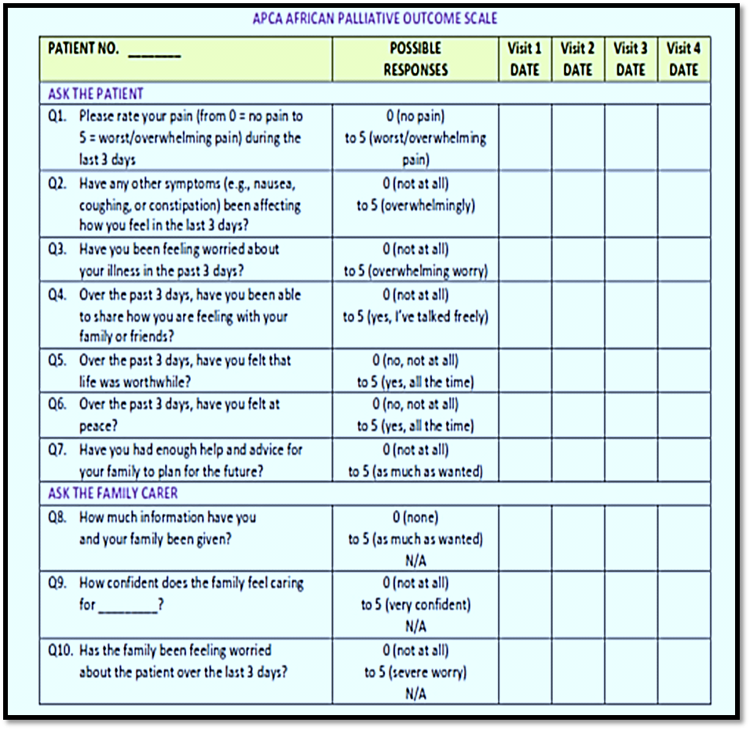
The APCA African Palliative Outcome Scale
Advantages: quick, simple to use, and provides three scales in one [numbers, words, and the physical hand].
Disadvantages: this tool which only addresses pain as a single domain in addition to others affecting a patient’s life requires a degree of staff training to ensure its consistent application. Additional research is ongoing to validate its use in different population and settings.
Pain Assessment in Advanced Dementia Scale [PAINAD]: Slide 34
The PAINAD is an observation-based pain assessment tool for patients with advanced cognitive decline due to dementia whose pain is difficult to detect as a result of which get undertreated for their pain. This tool applies five items [breathing, negative vocalizations, facial expression, body language, consolability], with each item’s intensity assessed on a score of 0-2, and finally an overall score of 0-10 is determined – ‘0’ representing ‘No pain’ and ‘10’ representing ‘Severe pain’.
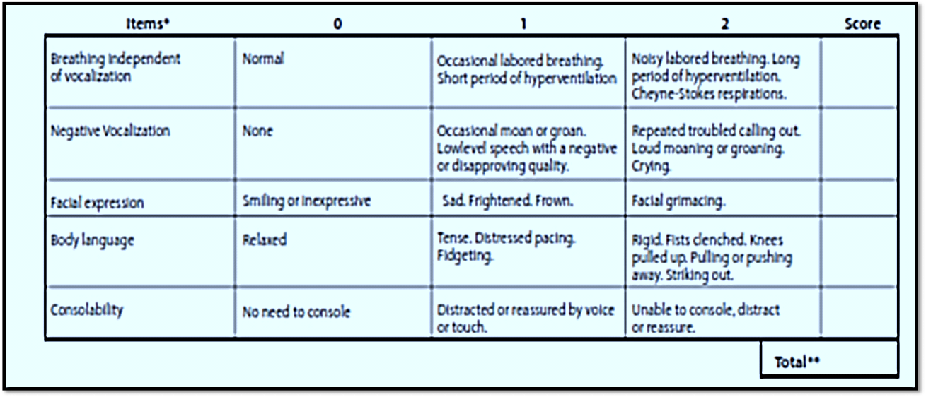
The Pain Assessment in Advanced Dementia Scale
Advantages: useful among adults who are unable to report pain; it is quick to use and is easily reproducible.
Disadvantages: relies upon proxy indicators of pain rather than verbal self-reporting.

Universal Pain Assessment tool Slide 35
Advantages: simple, quick to do, easy to score, requires no reading/verbal skills, unaffected by gender/ethnicity/cultural issues, provides three scales in one [numbers, facial expressions and words], well-validated in children and adults.
Disadvantages: this tool is sometimes described to measure mood rather pain, and sad or crying faces not culturally universal.

Conclusion: Pearls
Slides 36-39
- Pain should be assessed based on the characters of the patient [e.g. age, cognitive ability, literacy].
- Using standardized pain assessment tools is important. Such tools need to be utilized to the best of the different clinical scenarios.
- Pain assessment is not an ‘academic’ exercise: every question gives the therapist information on pain etiology and certain first steps used to treat it.
- Pain intensity assessment clarifies the need for treatment:
- 0-3: no change of therapy necessary
- 4-7: analgesic therapy has to be changed
- 8-10: analgesic therapy has to be changed immediately [pain emergency]
- Pain quality indicates aetiology of pain.
- Neuropathic pain: ‘burning’, ‘shooting’, ‘electrical’
- Nociceptive pain: ‘dull’, ‘aching’
- Affective component: ‘terrible’, ‘unbearable’
- Pain aggravated by certain movements/positions or at certain times of the day helps identify aetiology
- Pain worst at early morning hours: pain due to inflammation
- Constant high pain levels: chronic pain disease
- Pain decrease: alleviating positions/situations
- Pain worse on coughing/sneezing: radicular pain
- Localization: e.g. differentiation between a radicular and non-radicular pain. A radicular pain is pain arising from compression or injury to the nerve roots and is characterized by a radiating pain along the dermatome distribution of that nerve. A non-radicular pain does not radiate, and usually arises from musculoskeletal causes.

Case example
[Narayan, 2010]
Mr. Nguyen, a 68-year-old Vietnamese man who immigrated to the United States in 1990, is brought to the ED by his daughter, who discovered that he'd been treating upper abdominal pain for several months with herbal tea. He's admitted after testing reveals stomach cancer. The nurse caring for Mr. Nguyen can see that he's a reserved man who tends to deny pain, and she's concerned that he may have a need for pain medication. With the help of an interpreter, the nurse performs a comprehensive pain assessment. She discovers that Mr. Nguyen has a history of being quite stoic, having refused pain medication when he was recovering from wounds incurred during the Vietnam War. She also discovers that he doesn't like to take pills; he believes that teas made from medicinal herbs are more helpful and that opioids have the "wrong energy." He feels he should accept "what is"-what life hands him, including pain-without complaining. Mr. Nguyen reports that he is a Buddhist and that he frequently copes with pain by using a breathing meditation practice. Mr. Nguyen's nurse is concerned that his pain may overwhelm his coping techniques. She explains that enduring too much pain has negative effects. Using his concept of promoting well-being by "balancing energy," she tells Mr. Nguyen how pain depletes the body's energy and how taking pain medication regularly can help keep this energy in balance. She stresses to Mr. Nguyen that she wants what's best for him and acknowledges his preference for using his own coping methods. However, she says, if the pain gets bad, he may want to consider other options. She encourages Mr. Nguyen to practice meditation because it's an evidence-based pain management technique and asks him how the staff can help with this practice. She also confers with the pharmacist about the herbal tea Mr. Nguyen had been drinking at home. The pharmacist says the herb has sedative and laxative effects and will have no adverse interactions with Mr. Nguyen's other medications. With the approval of his physician, the herb is included in the patient's medication profile. Mr. Nguyen's daughter prepares the tea for her father and the constipation Mr. Nguyen has had since being admitted resolves several hours later. He reports feeling much more comfortable. Finally, the nurse tells Mr. Nguyen that pain medications are available in concentrated liquid form that could be added to his tea. Mr. Nguyen says he might try the drops if his pain becomes unmanageable. The nurse recommends to the physician that morphine drops be included with his discharge medications when he's transferred to a palliative care program. Several days later, he asks his daughter to prepare the tea and to add one-half the prescribed dose of morphine drops. With meditation, herbal tea, and morphine drops, Mr. Nguyen's last days are both physically and culturally comfortable.

References
- Merkel SI, Voepel-lewis T, Shayevitz JR, Malviya S: The FLACC: a behavioral scale for scoring postoperative pain in young children. Pediatr Nurs. 1997 may-Jun;23(3):293-7
- Baker CM, Wong DL. QUEST: a process of pain assessment in children. Orthop Nurs 1987;6:11-21
- Powell RA, Downing J, Ddungu H, Mwangi-Powell FN. Pain History and Pain Assessment. In: Guide to Pain Management in Low-Resource Settings. International Association for the Study of Pain. Edited by Kopf A and Patel N. IASP. Seattle; 2010:67-78
- Breivik H, Borchgrevink PC, Allen SM, Rosseland LA, Romundstad L, Hals EK, Kvarstein G, Stubhaug A. Assessment of pain. Br J Anaesth. 2008 Jul;101(1):17-24. Epub 2008.
- Carlsson AM. Assessment of chronic pain. I. Aspects of the reliability and validity of the visual analogue scale. Pain. 1983;16(1):87-101.
- Eland JM, Coy JA. Assessing pain in the critically ill child. Focus Crit Care. 1990;17(6):469-75.
- Gracely RH, Dubner R. Reliability and validity of verbal descriptor scales of painfulness. Pain. 1987;29(2):175-85.
- Herr KA, Mobily PR. Comparison of selected pain assessment tools for use with the elderly. Appl Nurs Res. 1993;6(1):39-46.
- Herr K, Bjoro K, Decker S. Tools for assessment of pain in nonverbal older adults with dementia: a state-of-the-science review. J Pain Symptom Manage. 2006;31(2):170-92.
- McLafferty E, Farley A. Assessing pain in patients. Nurs Stand. 2008;22(25):42-6.
- Powell RA, Downing J, Harding R, Mwangi-Powell F, Connor S; APCA. Development of the APCA African Palliative Outcome Scale. J Pain Symptom Manage. 2007;33(2):229-32.
- Schofield P. Assessment and management of pain in older adults with dementia: a review of current practice and future directions. Curr Opin Support Palliat Care. 2008;2(2):128-32.
- Norval DA, Adams V, Downing J, Gwyther L, Merriman A. Pain management. In: Gwyther L, Merriman A, Mpanga Sebuyira L, Schietinger H, editor. A clinical guide to supportive and palliative care for HIV/AIDS in Sub-Saharan Africa. Kampala, Uganda: African Palliative Care Association; 2006: pp 43-64
- Royal College of Physicians, British Geriatrics Society, and British Pain Society. The assessment of pain in older people: national guidelines. Concise guidance to good practice series, No 8. London: Royal College of Physicians; 2007
- Wilson D, Hockeberry MI. Wong’s Clinical Manual of Paediatric Nursing, 7th ed, St. Louis: Mosby;2008
- World Health Organization. Palliative care: symptom management and end-of-life care. Integrated management of adolescent and adult illness. Geneva: World Health Organization; 2004
- McCaffery, M., & Beebe, A. Pain: Clinical Manual for Nursing Practice. Baltimore: V.V. Mosby Company.1993
- Wong, D. and Whaley, L. Clinical handbook of pediatric nursing, ed., 2, p. 373. St. Louis: C.V. Mosby Company. 1986
- Handbook of Pain Assessment. Eds. Dennis C. Turk and Ronald Melzack, 2nd Edition. The Guilford Press. 2001.
- Narayan MC. Culture's Effects on Pain Assessment and Management. Am J Nurs. 2010;110:4:38-47

Websites:
- Eland Color Scale: Directions for Use. Available at: www.painresearch.utah.edu/cancerpain/attachb6.html Accessed on July 3, 2012
- International Association for Hospice and Palliative Care: www.hospicecare.com/resources/pain-research.htm Accessed on July 3, 2012
- National Institute of Health and Pain Consortium: http://painconsortium.nih.gov/pain_scales/index.html Accessed on July 3, 2012
- Initiatives on Methods, Measurement and Pain Assessment in Clinical Trials (IMMPACT) www.immpact.org Accessed on July 3, 2012

